**Guideline Leaflet M02: Loan Fund Application Form**

This application form is for churches seeking a loan from the BU Loan Fund in connection with a church building project or purchase of land or property for church use.

If you are seeking a loan to help finance a **Manse Purchase** please use Loan Fund Application Form M04 (Manse Purchase)

This Guideline Leaflet is regularly reviewed and updated.  To ensure that you are using the most up to date version, please download the leaflet from the BUGB website at [www.baptist.org.uk/resources](http://www.baptist.org.uk/resources)

The date on which the leaflet was last updated can be found on the download page.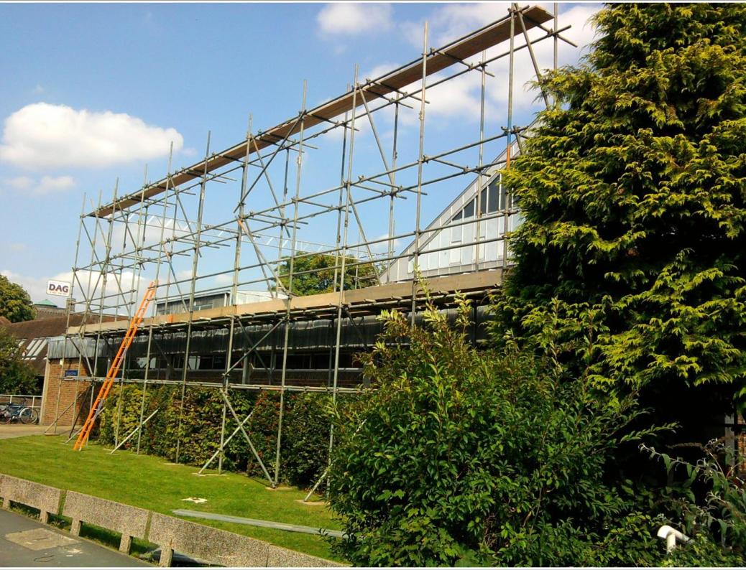

**M02: BAPTIST UNION LOAN FUND   
APPLICATION FORM**

This form is for churches seeking a loan in connection with a church building project or purchase of land or property for church use. If you are seeking a loan to help finance a **Manse Purchase** please use Loan Fund Application Form M04 (Manse Purchase)

|  |  |
| --- | --- |
| **Name of Church** |  |
| **Church Address** |  |

|  |  |  |
| --- | --- | --- |
| **Name of Church Contact** |  | |
| **Role in Church** |  | |
| **Address** |  | |
| **Daytime Telephone Number(s)**  Please indicate whether these are home, church, work or mobile numbers. If more than one number given please indicate which one you would prefer us to use. | |  |
| **Email address** |  | |

|  |  |  |
| --- | --- | --- |
| **LOAN REQUESTED** | **£** | **OVER 10 YEARS / 15 YEARS** |
| **PROJECT (*Please briefly describe below what you want to do with the loan*)** | | |
|  | | |

|  |  |  |
| --- | --- | --- |
| **PROJECT – SUMMARY FINANCIAL INFORMATION** | £ |  |
|  |  |  |
| **Gross Project cost – to include all expenses, contingency provision**  These costs will need to be explained further in a separate document |  | **A** |
|  | |  |
| **FUNDING – CHURCH MONEY** | |  |
| Funds already spent |  |  |
| Funds in hand allocated to the project |  |  |
| Confirmed/promised loans from Church Members/Attenders |  |  |
| Promised gifts from Church Members/Attenders |  |  |
| Confirmed Grant Funding |  |  |
| Other sources of income/donations (please specify) |  |  |
|  |  |  |
|  |  |  |
|  |  |  |
|  |  |  |
| **Total** |  | **B** |
| **FUNDING - EXTERNAL LOANS** [These should not exceed 70% of the Gross Project Cost (A)] | |  |
| Baptist Union Loan Fund |  |  |
| Baptist Building Fund |  |  |
| Particular Baptist Fund |  |  |
| Association |  |  |
| Other (please specify) |  |  |
|  |  |  |
| **Total** |  | **C** |
| **SUMMARY AND RECONCILIATION** | |  |
| Total from Church(B) |  |  |
| Total from External Loans (C) *[Not more than 70% of A]* |  |  |
| **Grand Total – to balance with Gross Project Cost above (A)** |  |  |

|  |  |  |  |  |  |  |  |  |  |  |  |
| --- | --- | --- | --- | --- | --- | --- | --- | --- | --- | --- | --- |
| **ABOUT YOUR CHURCH** | | | | | | | | | | | |
| **Date formed** |  | **Number of Members** | | | | | |  | | | |
| **Average attendance at your most popular service** | | **Adults** | |  | | | | **Under 18s** | | |  |
| **Total number of Charity Trustees  (Ministers, Deacons, Elders)** | |  | | | | | | | | | |
| **Please give the name of your Minister (s)** | |  | | | | | | | | | |
| **If you are currently in Pastoral Vacancy please give the name of your Moderator.** | |  | | | | | | | | | |
| **Which Baptist Union are you in membership with?** | | **BUGB** |  | | **BUS** | |  | | **BUW** |  | |
| **Which local Baptist Association are you in membership with?** | |  | | | | | | | | | |
| **Who is your Regional Minister?** | |  | | | | | | | | | |
| **If you are a Registered Charity please give your Charity Number** | | | | | |  | | | | | |
| **Has your church become a ‘Charitable Incorporated Organisation’ or a ‘Company Limited by Guarantee’?** | | | | | |  | | | | | |
| **Who are the church’s Property Trustees?** e.g. BUC, Private Trustees.  *If you do not have the BUC or another Baptist Trust Company as your Property Trustees please make sure you read the notes on pages 3-4 of the Guidance Notes* | | | | | |  | | | | | |
| **Do they have the property deeds?** | | | | | |  | | | | | |
| **Please list your current property assets.** e.g. Chapel and grounds, manse | |  | | | | | | | | | |
| **Are your buildings listed?** | |  | | | | | | | | | |
| **Who are your Insurers?** | |  | | | | | | | | | |

|  |
| --- |
| **FURTHER INFORMATION**  **Please include the following documents with your application**  **CHURCH INFORMATION DOCUMENT** (MAXIMUM 2 SIDES OF A4)  This should tell us something of your church and its mission. We would like to know something about each of the following.   * Your history, present situation and future vision for the church. * Your local community and your work and witness within it. * How the project will help to further the work of your church locally.   **CHURCH ACTIVITES LIST** (See example in the Guidance Notes)  Please provide us with information about your regular church activities and how your church premises are used. The easiest way to do this is to provide a list of what happens each day – which includes   * Church run activities on church premises * Church run activities held elsewhere * Activities on church premises run by other people/organizations |

|  |  |  |  |  |
| --- | --- | --- | --- | --- |
| **ABOUT YOUR CHURCH FINANCES – SUMMARY INFORMATION** | | | | |
| **When is your Financial Year?**  e.g. January to December | | |  | |
| **In your last complete financial year,  how much was given to the church as offerings?** | | |  | |
| **How much do you hope to receive this financial year in offerings?** | | |  | |
| **How much have you received in this financial year as offerings up to the end of the last complete month?** | | |  | |
| **In your last complete financial year, how much Gift Aid did the church recover?** | | |  | |
|  | | | | |
| **Please supply the requested information for the last three completed financial years (please give the relevant years in the column headings** | | | | |
| Financial Year |  |  | |  |
| Gross Annual Income (General Fund) |  |  | |  |
| Net surplus or deficit (General Fund) |  |  | |  |
| Contribution to Home Mission |  |  | |  |
| Contribution to BMS World Mission |  |  | |  |
|  |  | | | |
| **If you have an existing loan or mortgage please provide details of amount borrowed, outstanding and payment terms.** |  | | | |
| **Please provide us with any other information about your church finances that you feel may be relevant to your loan application, and confirmation of how you will fund the loan repayments.** |  | | | |

|  |  |  |  |  |
| --- | --- | --- | --- | --- |
| **PROFESSIONAL ADVISORS (BUILDING PROJECTS ONLY)** | | | | |
| Please give the names of the relevant people working on this project. We will need details of their Professional Indemnity Insurance (PII). Please indicate whether these are enclosed with this form or whether they will follow later. | | | | |
|  | Name (Individual and Firm) | | PII included | PII to follow |
| Architect |  | |  |  |
| Structural Engineer |  | |  |  |
| Surveyor |  | |  |  |
| Quantity Surveyor |  | |  |  |
|  |  | |  |  |
|  |  | |  |  |
| Please indicate (if appropriate) which of the above individuals/firms is running the building contract? | |  | | |
| Who will be responsible for dealing with Construction (Design and Management) Regulations 2015? | |  | | |
| Who will supervise the building project overall on behalf of the church? | |  | | |

|  |  |
| --- | --- |
| **Project Plans and Approvals  Please answer the questions relevant to your project/purchase** | |
| Have plans been prepared? |  |
| Have your Church Members approved the design and project plan? |  |
| Have your Church Members approved the proposed purchase of land or property? |  |
| Have your Property Trustees approved the project? |  |
| Have you received planning permission? |  |
| Have you received Buildings Regulation Approval? |  |
| If your church is a listed building have you received Listed Buildings Consent? |  |
| If you are in a Conservation area have you received Conservation Area consent? |  |
| Is your building affected by any Restrictive Covenants, Rights of Light, or Party Wall legislation? [If ‘yes’ please provide details separately] |  |

|  |  |
| --- | --- |
| **Timescale** |  |
| (For a building project) When do you hope to start work? |  |
| (For a purchase) When are you hoping contracts will be exchanged? |  |
| When do you anticipate you will need the loan to be drawn down? |  |

|  |  |
| --- | --- |
| **SIGNATURES**  We confirm that to the best of our knowledge the information in this application and the accompanying documentation is correct.  This form should be signed by three people who carry leadership responsibility within the church and are recognised as being the church’s Charity Trustees. They are making this loan application on behalf of the church. | |
|  | |
| **Name and Role within church** | **Signature** |
|  |  |
| NAME |  |
| ROLE |
|  |  |
| NAME |  |
| ROLE |
|  |  |
| NAME |  |
| ROLE |

|  |  |
| --- | --- |
| **Date of Application:** |  |

**Please ensure that you complete the table on page 7 to indicate which documents you have enclosed.**

**PLEASE NOTE:**

Applications should ideally be sent by email to [tchowns@baptist.org.uk](mailto:tchowns@baptist.org.uk) or as electronic documents on a CD sent to the address below. Please ensure that all electronic documents are clearly numbered and named. All documents requiring signatures should be printed off, signed and then scanned before sending.

If sending paper copies by post please use the address below and send **two copies** of everything for loans of up to £750,000 or **three copies** for loans above £750,000.

Tim Chowns, Loan Fund Officer

Baptist Union Corporation Limited

Baptist House, PO Box 44

129 Broadway, Didcot OX11 8RT

Telephone Number: 01235 517708 Email: [tchowns@baptist.org.uk](mailto:tchowns@baptist.org.uk)

|  |  |  |
| --- | --- | --- |
| **Please number all the documents you are enclosing and indicate the relevant number in the ‘Doc Nos’ column. Use the ‘Notes’ column to indicate ‘N/A’ or ‘To Follow’ if appropriate** | | |
| **DOCUMENT** | **Doc Nos** | **Notes** |
| Application Form – fully completed and signed by three Charity Trustees |  |  |
| Signed copy of the minutes of the Church Members Meeting when the project or purchase was agreed. |  |  |
| Signed copy of minutes of the Church Members Meeting when the application for this loan was agreed. |  |  |
| The last three years audited/independently examined church accounts. If your most recent accounts have yet to be finalised please send us a copy of the draft accounts. |  |  |
| Budget and information to date for the current financial year |  |  |
| Church Information Document (see page 3) |  |  |
| Church Activities List (see page 3) |  |  |
| Pledge List (see section 2 in the Guidance Notes) |  |  |
| Copy of the Valuation/Survey Report (for land/building purchases only) |  |  |
| Copy of your Business Plan for this project (if you have one) |  |  |
| LEPs who have another Denominational Trust Company as their Property Trustees should also include written confirmation that that they will be willing to consent to the BUC taking a Legal Charge on the property. |  |  |

|  |  |  |
| --- | --- | --- |
| **The following documents are also required for building projects** | | |
| Plans showing the existing buildings and the proposed development (see section 3 in the Guidance Notes) |  |  |
| Planning permission and/or other appropriate consents  (see section 3 in the Guidance Notes) |  |  |
| Evidence of PPI Cover for your professional advisors listed on page 5. |  |  |
| A Summary Statement that explains how you have calculated the Gross Project Cost |  |  |
| A copy of the approval of the project given by your Property Trustees |  |  |
| Confirmation of the church’s current insurance cover |  |  |

|  |  |  |
| --- | --- | --- |
| **FOR SCOTTISH CHURCHES ONLY (See section 5 of the Guidance Notes)** | | |
| Copy of your Church Constitution |  |  |
| Name and contact details of the solicitor who will act for your church |  |  |

Support Services Team, Baptist Union of Great Britain,  
 Baptist House, PO Box 44, 129 Broadway, Didcot OX11 8RT

Tel: 01235 517700 Email: [legal.ops@baptist.org.uk](mailto:legal.ops@baptist.org.uk) Website: www.baptist.org.uk

Registered CIO with Charity Number: 1181392

Date Reviewed: Feb 205